



Elburton Primary School
Special Educational Needs and Disabilities (SEND)
SEND Information Report

Special Needs Co-ordinator (SENCO): | Lisa Birnie
Contact details: | Tel: 01752 404489  Email: lisa.birnie@elburtonprimary.co.uk
Website link to SEND policy: | Elburton Primary School - SEND (elburtonschool.com)  SEN and disabilities Policy 2025
Website link to Accessibility policy: | Accessibility Policy
Website link to Local Offer: | SEND Local Offer - Plymouth Online Directory

Reviewed: | September 2025
Next Review Date: | September 2026

Elburton Primary School
‘Inspiring todays children for tomorrow’s world’

Our Mission Statement:

The Elburton Core Values
Safe
Together we will be caring and thoughtful in everything we do.
Inspire
Together we will not let disadvantages be an obstacle to success
Pride
Together we take pride in everything and always do our best.
Flourish
Together we will achieve the best outcomes for all.
Respect
Together we will act with integrity and honesty

At Elburton Primary School, we are committed to providing a rich and comprehensive curriculum that meets the needs of every child.
At Elburton, inclusivity, happiness, and ambition define our learning environment. We empower our staff to ensure accessibility for all students, fostering a culture where every child can thrive.
Our core values – Safety, Inspiration, Pride, Flourishing, and Respect – serve as the guiding principles woven throughout our curriculum, teaching, learning, and behaviour. They encapsulate everything we stand for, ensuring clarity and coherence for all primary school stakeholders.

There may be times when children need extra support with their learning. It is hoped that this Special Educational Needs Information Report will inform you of the types of support available for your child and how this support can be accessed. This report makes reference to the Accessibility Policy and Equality Information Policy

Contents:
1. What does having a Special Educational Need mean?
2. How do we identify the special educational needs of pupils?
3. What support is available for pupils with special educational needs?
4. How will the school know my child needs special educational provision?
5. How is my child’s progress monitored?
6. What other support is available within the Local Offer?
7. Who is responsible for the pupils with SEND at Elburton Primary School?
8. Who else can I contact for advice and support for my family?
9. Who is responsible for Safeguarding and Child Protection at Elburton?
10. How do we consult with parents/carers and children about their needs?
11. How can I let the school know I am concerned about my child?
12. How do we ensure that teaching and support staff have the skills and expertise needed to support pupils with special educational needs?
13 How is support for improving social and emotional wellbeing provided?
14. What extra-curricular activities are available for pupils with special educational needs?
15. How do parents/carers and pupils with SEND share their views or concerns, and work with the school?
16. If I have a query about the support my child receives, what do I do?
17. If I am not happy with the support my child is getting, what can I do?
18. What happens when my child moves from class to class or to another school?
19. How accessible is the school for my child with SEND?
20. Where can I find further information about the school’s approach to pupils with SEND?
21. How accessible is this report?

1. What does having a Special Educational Need mean?
The Special Educational Needs Code of Practice (2015) states that:
A child or young person has SEND (Special Educational Need and/or disability) if they have a learning difficulty or disability which calls for special educational provision to be made for them.
A child of compulsory school age or a young person has a learning difficulty or disability if they:
- have a significantly greater difficulty in learning than the majority of others of the same age
- have a disability which prevents or hinders them from making use of facilities of a kind generally provided for others of the same age in mainstream schools.
This means that a pupil may need:
- special resources or equipment to help them in the classroom
- to be part of a small group with an adult to help them with their work, their social skills or their emotional well-being
- to work with someone specially trained to help them in the area that they need (usually someone from outside school)
- to have an IEP (Individual Education Plan) and Provision map, which will be shared with parents/carers
Children who have English as an Additional Language (EAL) are not regarded as having a learning difference, if the only difficulties are language barriers.
Health conditions and/or physical disabilities which require special educational provision to be made will be covered by this SEND definition.

2. How do we identify the special educational needs of pupils?
Here at Elburton, the progress and attainment of all pupils is reviewed termly by teachers and the Senior Leadership Team who organise support to meet needs across the school. This ensures that pupils who need further support are identified swiftly. Children’s progress is measured against National Curriculum expectations for their year group. Some children may not yet be secure with the expectations from a previous year group, so steps to support them will be planned appropriately during termly pupil progress meetings. As well as termly assessment, a concern may be raised by any member of school staff at any time. This will be discussed and assessed to decide on the best form of support and will then be reported back to parents/carers.
If a pupil is identified as not making progress, they can be assessed against the SEND Code of Practice (2015) which has four broad categories of need.
These include:
- Communication and interaction (C & I) which includes speech and language, and social communication difficulties (including autism)

- Cognition and learning (C & L) which is where a pupil learns at a slower pace than others in their year group

- Social, emotional and mental health (SEMH) which includes pupils with challenging behaviour, anxiety, ADD (attention deficit disorder), ADHD (attention, deficit, hyperactivity disorder) or attachment disorder

- Sensory and/or physical needs (S & PN) which includes hearing difficulties, visual difficulties, mobility difficulties and sensory processing difficulties.
Our school can provide for pupils with these needs. All pupils assessed as having a Special Educational Need will have one or more of these categories recorded on the SEND register.

3. What support is available for pupils with special educational needs?
At Elburton, the majority of pupil’s needs will be met through ordinarily available (universal) provision. Should a child be identified as needing targeted provision, their needs will be discussed with the SENCO at termly meetings, and will be communicated to parents/carers swiftly. Should a pupil present with significant and persistent learning difficulties, more specialist intervention and provision may need to be considered.
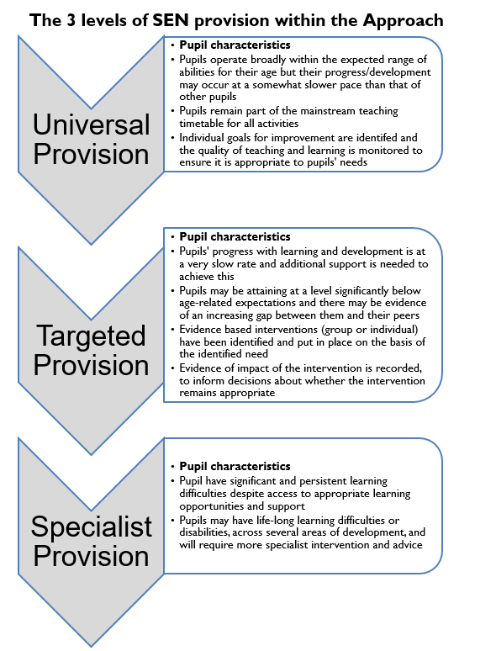
Our school is an inclusive learning environment, and we value each child as an individual. When additional needs are identified, we ensure a team is built around the pupil to support their progress and attainment. This team includes parents and carers, the class teacher, teaching assistants, the SENCO and any relevant outside agencies who may be involved in providing additional support, strategies and/or advice. The information from the team supports the identification of barriers and difficulties within learning. Teachers then use this information to ensure needs are planned for.
Teachers are responsible for ensuring quality first teaching (QFT) is adapted to meet the needs of any child with SEND, and a responsive teaching model is applied in all cases. This means that teachers adapt learning to meet the needs of children, regardless of their SEND status and respond to the individual needs of children in their classrooms.
Some pupils may require further assessment and observation by the SENCO. This will support the process of identification and help to determine whether they require a bespoke programme of support. Support will then be planned to suit the individual needs of the child within the school’s existing provision and bank of resources using evidence-based research.
Children identified as requiring targeted support will also have an Individual Education Plan (IEP) with individualised targets, and where necessary, adjustments to provision recorded on a Provision map.
Once a child’s need has been identified, some of the following adaptations to your child’s education could take place:
- Modification of teaching approach
- Level of adult support & time spent on a specific task
- Quantity of work to be completed and the level of difficulty
- Bespoke provision through a carefully tailored curriculum
- Scaffolding of learning tasks
- Provision of specialist equipment
- Small group work/intervention
- Individual work with an adult.

The range of strategies, interventions and adaptations could also include:
- English & Maths conferencing sessions targeting specific areas of need
- RWInc targeted support or individual tutoring
- 1:1 Daily reading and/or Precision Teaching
- Emotional literacy support groups (managing emotions, self-esteem, friendships, anxiety and confidence development)
- Grieving in Puddles (bereavement therapy)
- Small group interventions such as Lego therapy, Culinary therapy or Touch-typing
- The provision of a safe/calming space within the classroom/The Canopy
- Visual timetable/visual cues
- Manipulatives, models and images
- Support through a multi-sensory approach
- Wobble-cushion and/or Movement breaks
- PECS (Picture Exchange Communication System).
- Use of The Canopy as part of a bespoke timetable

Sometimes we access support from other people outside of school. Where a need has been identified, the SENCO will ask your permission to seek advice and support from an appropriate agency. This will help the school, and you, to understand your child’s needs better, and it will help us to support them more effectively in school. These may include:
  - Multi Agency Support Team (MAST)
  - Mental Health Support Team (MHST)
  - Communication Interaction Team (CIT)
  - SEND Advisory Services
  - Plymouth Advisory Team for Sensory Support (PATSS)
  - Outreach support from specialist provision schools such as Mill Ford or ACE
  - The Educational Psychology Service
  - Plymouth Information Advice and Support Service (PIASS)
  - Social Care professionals
  - School Nurse
  - Child and Adolescent Mental Health Service (CAMHS)
  - Child Development Centre (CDC)
  - NHS Speech and Language Team.

It may be that your child’s needs mean we need to secure:
- Extra equipment or facilities
- Further training for our staff
- External specialist expertise

If that’s the case, we will consult with external agencies to get recommendations on what will best help your child access their learning.

Information about the Local Authority’s Local Offer for pupils and young people with SEND and their families, as well as the above services, can be found on the Plymouth Online Directory (POD): SEND Local Offer - Plymouth Online Directory

4. How will the school know my child needs special educational provision?
The adults working with your child will know if your child needs special educational provision because little or no progress is being made despite high quality teaching and adaptions. Teachers will know this because:

- they continually assess the pupils as part of their daily teaching. If needed, some pupils will then be taken for conferencing sessions as part of a small group or on their own with an adult
- they meet termly to look at the progress all pupils are making and identify any who are not making progress, or who have made slow progress, so that they can support them
- they will review support and interventions every 6-8 weeks to make sure progress is being made
- school will be alerted by parents with their concerns
- school will be alerted by other professionals working with the child or family outside of school.
Pupils identified as having a special educational need will have an IEP (Individual Education Plan) written for them setting small, achievable targets. Alongside a provision map to record adjustments to provision. These will be shared with parents and reviewed termly.
If a multi-agency response is required, targets may be documented through a Multi Agency Support Plan (MASP) or Team Around Me. This helps to co-ordinate the advice from multiple agencies.
If the child struggles despite multi agency working and high-quality targeted provision, the team around the child may consider if an Educational Health Care Plan would be appropriate. A child with an Educational Health Care plan will have a carefully constructed plan to meet their individual needs. This is reviewed annually, alongside termly meetings (if required) to set and review short term targets. It may be necessary to apply for additional funding to secure specialist expertise or resources through this process.
At Elburton, we have a clear system in place within the school to identify potential special educational needs for a child and consider early identification of SEND to be vital.
- We follow the SEND Code of Practice (2015)
- All class teachers track and monitor the data of pupil’s progress and attainment throughout the school year. Where a child is making limited progress, or achieving below age related expectations, the class teacher monitors to ensure this is not due to any underlying special educational need
- Classroom observations and learning walks by school leaders are conducted to ensure that any barriers to learning are supported effectively. Any concerns are shared with the SENCO
- If a teacher has a concern regarding a child’s progress, they refer directly to the SENCO after consultation with parents/carers. The SENCO subsequently uses appropriate assessment tools to further investigate concerns raised through the observation and monitoring processes
- Where needed, the SENCO will refer to outside agencies to provide support in the identification and assessment of any barriers to learning
- The SENCO can support parents in liaising with medical professionals where an underlying medical condition is causing barriers to learning, to aid the process of identification
- Where behaviour is causing barriers to learning, the SEND and Pastoral team work closely with families to identify what the cause might be and support as required.

The Graduated Response
The Graduated Response to SEND shown below is a 4-part cycle through which earlier decisions and actions are revisited and refined, leading to a growing understanding of pupils’ needs and of what supports the pupil in making good progress. The school follows the graduated approach to inclusion and an assess, plan, do, review cycle to help target the support a child requires.
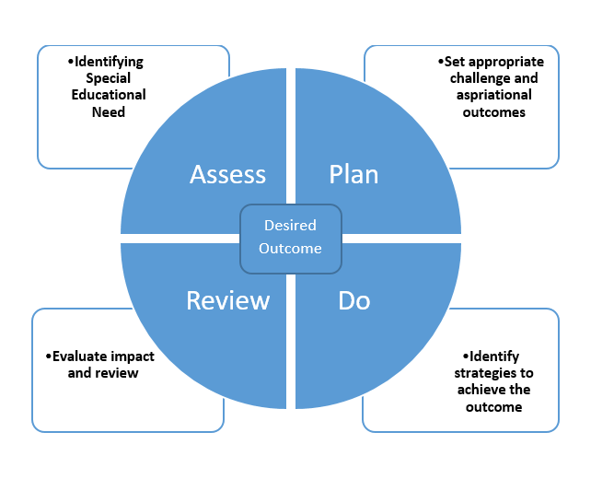

5. How is my child’s progress monitored?
The effectiveness of provision offered to SEND pupils at Elburton is assessed regularly. Pupils on the SEND register have their IEP targets and Provision maps reviewed on an ongoing basis to ensure that targets are relevant and appropriate to their needs. New targets are set termly and are specifically geared around their barriers to learning. The class teacher and SENCO also check that the child is making good progress within any group or targeted work that they take part in. The progress of pupils with an EHCP is also formally reviewed annually at review meetings.
The SENCO oversees and monitors the effectiveness and suitability of provision and the support in place. Monitoring may be conducted through discussions with parents, pupils and staff, lesson visits, monitoring of interventions, book looks and pupil progress meetings.

6. What other support is available within the Local Offer?
The child’s class teacher remains the key point of contact for parents. The class teacher is supported by the Senior Leadership Team, SENCO and Pastoral team. They can support parents and children to access additional targeted provision:
Support for Social, Emotional and Mental Health
We recognise the need for children to feel settled, safe and supported to be able to achieve their best both in and out of school. We endeavour to create a school where all children have a voice and feel heard. All staff are advocates for those with SEND and implement measures to promote inclusion and prevent bullying. Additional support can include:
- The Designated Safeguarding lead can liaise with Social Care professionals, including accessing support from the Multi Agency Safeguarding Hub.
- The Designated Safeguarding lead can signpost access to parenting advice and support through referral to parenting programmes (for example: Solihull/The Incredible Years).
- The SENCO can support with requests for Learning Mentor support, Family Support Workers and therapeutic interventions through the Multi Agency Support Team (MAST). This includes access to individual or group interventions from the Mental Health Support Team (MHST).
- Pastoral interventions which can be implemented according to need. This may include scheduled check ins, nurture provision, 1-1 or small group sessions with our Emotional Literacy Support Assistant (ELSA). Our Pastoral Leader is also able to deliver support though interventions such as Grieving in Puddles for grief and loss and is a Trauma Informed Practitioner and STORM trained.
- Liaison with outside agencies for advice and support. This could be from a range of professionals such as an Educational Psychologist, The Child and Adult Mental Health Team (CAMHS) and the Speech and Language Therapy team.
Support for Communication and Interaction
  - Speech and Language concerns may result in a referral to Speech and Language Therapy with Livewell. In-house Speech and Language support is also available through our SaLT therapist Nicola Blundell and SaL Teaching Assistant Emma Stuckey.
  - Request to outside agencies for advice such as the Communication and Interaction Team (CIT) and the Educational Psychology Service.
  - Interventions such as BLAST, Intensive interaction, Attention bucket, Lego Therapy/Culinary Therapy and Colourful Semantics can be implemented in school according to need
  - A total communication approach (TCA) is used across the school including, visuals, Makaton and cued articulation.

Support for Cognition and Learning
Regular meetings between class teachers and the SENCO take place where teaching staff can discuss concerns regarding progress or attainment using accompanying Graduated Response checklists. Specific tailored interventions such as: 1:1 Phonics Tutoring, Daily Reading, Read Write Inc and Precision Teaching can be implemented according to need.
Physical and Sensory
Referral to outside agencies can be made according to need. These include (but are not limited to) the Plymouth Advisory Team for Sensory Support (PATSS) for visual and sight impairment and deaf and hearing impairments, the Bladder and Bowel Team, Occupational Therapy Service and Physiotherapists. School staff are happy to work in collaboration with advisory teams to support the implementation of recommendations. In school, there may be need for additional support resources to be used as advised, for example, wobble cushions, sit on wedges, writing slopes and specialised equipment.
Medical
For children with medical and on-going treatment needs that require careful management throughout the school day, regular meetings with the SENCO should take place. Meetings may run through the TAM process and can involve the wider medical team who will be able to discuss the child’s specific needs. It may be necessary to seek advice from the Children’s Community Nursing Team. Medical Care plans will be drawn up with the team involved in supporting the child.

7. Who is responsible for the pupils with SEND at Elburton School?
Every teacher and teaching assistant has responsibility for the day-to-day teaching of pupils with SEND in their class.
The Head Teacher, SENCO, Pastoral Support Team and Senior Leadership Team are responsible for ensuring support meets the needs of the pupils. They also provide support and advice to teaching staff and parents/carers where required. This team have full responsibility for the learning, care and safety of all pupils.
If you have a cause for concern regarding your child’s education or social and emotional development, you can raise a concern with the following people:

Lisa Birnie is the school’s Special Educational Needs Coordinator (SENCO). She is responsible for working with staff, outside agencies, the local authority SEND Team and parents to ensure that pupils with SEND from Preschool to Year 6 are supported appropriately. She is accredited with the PgCert National Award for Special Educational Needs Coordination from Plymouth University.
Lisa.birnie@elburtonprimary.co.uk

Taffeta Sammels is the Preschool SEND Lead She is responsible for working with staff, outside agencies, the local authority SEND Team and parents to ensure that pupils with SEND in Preschool are supported appropriately. She is undertaking her National Professional Qualification for SEND.
Taffeta.sammels@elburtonprimary.co.uk


Lisa Clarke is the school’s Pastoral Support Lead. She works with pupils and families who may need support for a range of reasons, such as managing emotions, routines at home, parental mental health or supporting changes at home. She is also the schools Deputy Designating Safeguarding Lead. She has achieved the Level 5 Diploma, with Trauma Informed School UK Practitioner status. She also runs the schools Young Carers and Service children’s groups and has a therapy dog, called Reggie.
Lisa.clarke@elburtonprimary.co.uk



Emma Johnson – SEND Emma Phillips – SEND Support
Teacher - The Canopy KS1

Further support can be requested from our SEND Governor Carolyn Haynes, whose details can be requested from the school office. She can provide support on how other bodies, including health and social services, local authority support services and voluntary organisations, can help to meet the needs of pupils with special educational needs.
If you would like a meeting with any of these members of staff, please drop into the school office or contact them via the school number 01752 404489. They can also be reached directly via email.
8. Who else can I contact for advice and support for my family?
PIASS (Plymouth Information Advice and Support for SEND) can provide impartial and confidential information and support for parents and carers which can include:
- Helping with reports, letters and paperwork
- Attending meetings
- Signposting to other groups or organisations
- Visiting schools to help with making informed choices.
PIASS can be contacted directly on 01752 258933 or through their website www.plymouthias.org.uk

9. Who is responsible for Safeguarding and Child Protection at Elburton?
Designated members of staff for Child Protection are:


Ros Light
(Assistant Headteacher)
Deputy Designated Safeguarding Lead
Keith Smithers
(Headteacher)
Designated Safeguarding Lead

Lisa Clarke is our Pastoral Lead and Deputy Designated Safeguarding Lead. She is able to provide support and advice for our families and can be contacted through the school office. She is one of our designated members of staff for Child Protection.

All members of staff are regularly trained in and kept up to date with Child Protection information, including changes to the Keeping Children Safe in Education guidance. Children in school can speak to any member of staff if they are worried or need support.
A local authority in England must arrange for children and young people for whom it is responsible, and the parents of children for whom it is responsible, to be provided with advice and information about matters relating to the special educational needs and/or disabilities of the children or young people concerned.
It is the responsibility of the Designated Teacher for children who are Looked After, to oversee the writing and implementation of Personalised Education Plans (PEP). PEP meetings take place on a termly basis. Where a child is identified as having a Special Educational Need, targets within the PEP will reflect the provision required and will be shared with all parties including the social worker at the termly meetings. Funds can be acquired as necessary to meet specific targets as required. Our Designated Teacher for children who are Looked After is Lisa Birnie

10. How do we consult with parents/carers and children about their needs?
We recognise that the parent/school partnership is essential in supporting pupils to make good progress. It is also very important that we take parent and pupil views into account when planning appropriate provision. If a concern is raised by a member of the school staff, the barrier will be discussed and assessed by the Leadership Team and SENCO who will then report to parents/carers through a number of channels:
- The class teacher, SENCO or Senior Leadership Team will talk to you
- Concerns will be shared by the class teacher at parent consultation meetings
- You will be invited to a meeting in school with relevant staff.
Parents will be consulted if it is felt that the child requires individual targeted support; this would be specified on an Individual Education Plan (IEP) and Provision map. Children are actively invited to contribute to making their own targets and are shared during parent consultation meetings.
Children and parents are invited to contribute to Annual Review meetings where an Education, Health and Care Plan has been implemented.

11. How can I let the school know I am concerned about my child?
First, talk to your child’s teacher – they will endeavour to be available at the end of the school day if you wish to discuss your child. Alternatively, you can phone the school to make a specific appointment with a member of staff or share your concerns at one of our parent consultation meetings. If necessary, they will talk to the SENCO about your concerns. The teacher will let you know what will happen next.
If you are still concerned, you can ask to meet with the SENCO and Assistant Head (Lisa Birnie).
You could also ask to see the Head Teacher (Keith Smithers) or Assistant Head Teacher (Ros Light)

12. How do we ensure that teaching and support staff have the skills and expertise needed to support pupils with special educational needs?
Quality First Teaching is the key to ensuring the best progress for all children. We invest in our staff to provide a learning environment where high quality learning takes place across the whole school day. All teaching staff have QTS (Qualified Teacher Status), and school staff have been trained to provide a variety of interventions. Where a training need is identified, the school is committed to ensuring that needs are addressed. We regularly refresh our knowledge through In-Service Training (INSET) sessions after school and attend relevant training courses. In addition, the SENCO is an experienced, qualified teacher who has the skills and experience to work with staff, enabling them to work effectively with pupils who have a special educational need.
The SENCO regularly consults with professionals from a range of services to ensure children with additional needs are best supported, with recommendations from all professionals involved with the child. She attends Plymouth SENCO Briefings and MAST Co-ordinator Meetings to keep abreast of Local and National changes. Information from these briefings is also shared with staff.
Specific qualifications:
- Lisa Birnie has achieved the National SENCo Qualification
- Lisa Clarke holds a diploma as a Trauma Informed practitioner and has a PAWS accreditation for a Therapy Dog
- Lisa Clarke has completed the Emotional Literacy Support Assistant course
- Many of our TAs have been trained in a range of approaches, including Emotion Coaching, Lego Therapy, Precision Teach, Blank Levelling, CPI Safety Intervention Training, Trauma Informed and Colourful Semantics
- Taffeta Sammells, Emma Johnson and Emma Phillips are completing their NPQ SEND
13 How is support for improving social and emotional wellbeing provided?
At Elburton, we recognise the importance of listening to the views and experiences of pupils with SEND. We recognise that support for pupils’ social and emotional wellbeing is most effectively achieved through the nurturing and caring ethos of the school. Sometimes however, additional support may be required in this area. Where this is the case, the following strategies may be used (these are always based on the individual needs of the child):
- A trusted member of staff will be available for the child to go to
- Check-ins across the school day from an emotionally available adult
- A withdrawal space may be provided in or out of the classroom if needed to support calming strategies
- Planned nurture/pastoral sessions will take place between a staff member and the child (these can be on a 1:1 basis or as part of a small group)
- Access to ELSA groups to develop emotional resilience
- Access to specialist expertise, such as professionals working with Educational Psychology Service
- Referral to MAST, MHST or CAMHS if/when appropriate
- Recommendations for additional parent support.
Furthermore, we provide support for pupils to progress in their emotional and social development in the following ways:
- Pupils with SEN are encouraged to be part of the wider school offer and represent the school
- Pupils with SEN are also encouraged to be part of clubs to promote teamwork/ building friendships
- We run several nurture clubs at break and lunchtime for pupils who need extra support with social or emotional development
- We have a ‘zero tolerance’ approach to bullying.

14. What extra-curricular activities are available for pupils with special educational needs?
Our school has a range of extra-curricular activities available to all pupils, enabling pupils with special educational needs to engage in activities together with children who do not have special educational needs.

These include:
- A broad range of after school clubs available to children from Reception to Year 6
- Residential trips for KS2 children
- Breakfast and After School club available for children from Reception to Year 6
- Regular class trips in line with curriculum topics e.g. Historical or Geographical trips
- Lisa Clarke (Pastoral Lead) can signpost services to provide guidance on accessing extra-curricular opportunities outside of school
No pupil is ever excluded from taking part in these activities because of their SEN or disability and we will make whatever reasonable adjustments are needed to make sure that they can be included.

15. How do parents/carers and pupils with SEND share their views or concerns, and work with the school?
The Special Educational Needs Code of Practice (2015) states that schools must have regard to:
- the views, wishes and feelings of the child or young person, and the child’s parents
- the importance of the child or young person, and the child’s parents, participating as fully as possible in decisions, and being provided with the information and support necessary to enable participation in those decisions
- the need to support the child or young person, and the child’s parents, in order to facilitate the development of the child or young person and to help them achieve the best possible educational and other outcomes, preparing them effectively for adulthood.

Co-production, when applied effectively to supporting pupils with SEND, enables those involved to work together as equal partners to design, plan, deliver and review support and services in order to achieve shared outcomes. It recognises pupils, parents and carers, and professionals as assets that all have important contributions to make. Processes in place to support co-production are as follows:

- Surveys and questionnaires
- MASP/TAM meetings
- Parent Consultation evenings
- Annual reviews for pupils with Education, Health and Care plans (EHCPs)
- IEP reviews
- Person Centred Planning meetings
- Health Care Plans
- Transition meetings

16. If I have a query about the support my child receives, what do I do?

- Talk to your child’s class teacher
- Ask to meet the SENCO or a member of the Senior Leadership Team
- Ask to meet a member of the Pastoral Team

17. If I am not happy with the support my child is getting, what can I do?

We endeavour to work with parents at every opportunity. Teaching staff are available to speak to before and after school and there is always a visible presence from the Senior Leadership Team on duty at the school gates at the beginning and the end of the day.

However, at times a complaint may be raised. If this is the case, there are many ways of gaining a positive resolution:

- Talk to your child’s class teacher to see if they are able to offer a positive resolution
- Ask to meet the SENCO (Lisa Birnie)
- If the concern persists or is unresolved, an appointment to see a member of the Senior Leadership Team can be made through the office (01752 404489)
- Speak to our Chair of Governors Anna Clooke
- If you are still unsatisfied with the response, contact the Local Authority, Plymouth City Council and ask for the SEND 0-25 department (01752 307409)
Please feel free to request a copy of the school Complaints Policy from the school office or access it via Parents/Parental Information on the school website.

18. What happens when my child moves from class to class or to another school?

All pupils make visits to their new class and teacher in the summer term. Some pupils may need additional visits to ensure they feel confident and settled about the forthcoming changes. Teachers meet in the summer term to pass on information about pupils and their individual needs. Some pupils will have a transition booklet to take home over the holidays with pictures and information about their new class or school, a video may be produced to show key routines. Additional parent meetings with the SENCO and new class teacher may be required. Additional visits may be arranged to reassure more anxious pupils.

Key transition points and support in a nutshell:

Preschool to Key Stage 1:
  - Tours for potential new starters
  - ‘Stay and Play’ opportunities
  - SENCO and EYFS Lead (Chantal Churchill) discuss children who may require enhanced transition
  - Weekly opportunities for children to spend time within our setting to meet staff
  - Consultation with parents and any relevant professionals
  - SENCO and EYFS Lead to attend TAMS/parent meetings from other settings where needed for transitioning children
  - Information shared via the Early Years Transition Portal
  - SEN Information Report signposted to parents via Early Years induction packs.

Key Stage 1 to Key Stage 2:
  - Enhanced transition plans for children requiring additional transition days
  - Professional handover to include sharing of SEND information
  - Transition sessions for children to meet their new teacher before moving year group
  - Consultation with parents regarding transition plans and support.
  - Additional photo books, videos, social stories where required

Key Stage 2 to Key Stage 3:
  - Secondary placement open days
  - Enhanced transition for children requiring additional support
  - Opportunities to visit local Secondary placements in Year 5
  - Transition meetings between SEND leads in both settings
  - Transition meetings with parents/carers, children and relevant professionals
  - In the event of a school move, staff will liaise with your child’s new teacher to advise them on any special educational needs and send the relevant information and reports
  - Information share via the Secondary Transition Portal.

19. How accessible is the school for my child with SEND?

At Elburton, we ensure that wherever possible the environment and equipment used is accessible to all children regardless of their needs. Following assessment, we believe the school to be accessible to all children, however, should a problem arise, we would endeavour to make any reasonable adjustments to ensure accessibility is not a barrier. We are happy to discuss individual access requirements. A link to our school’s accessibility policy can be found by following the hyperlink below. A hardcopy of the policy can be requested via the school office if required.
Accessibility Policy

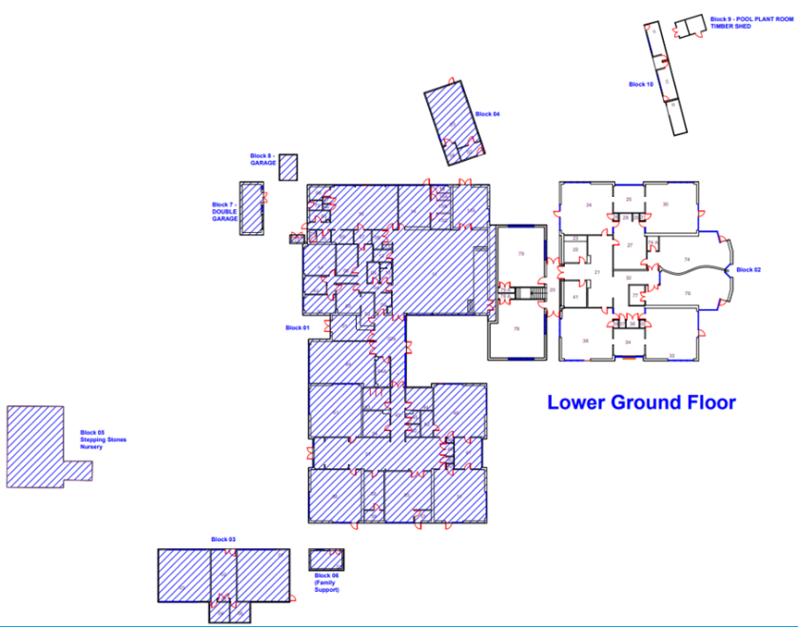
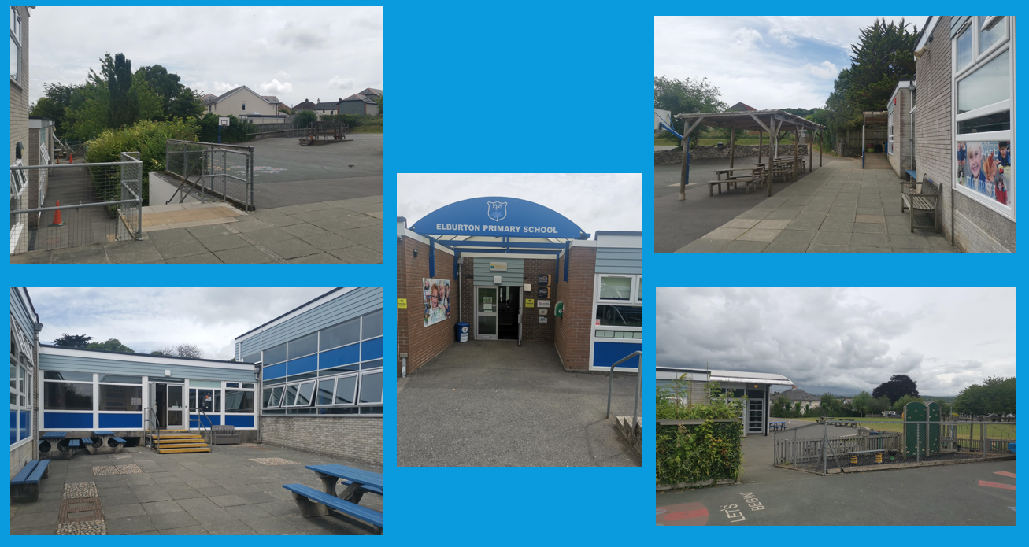
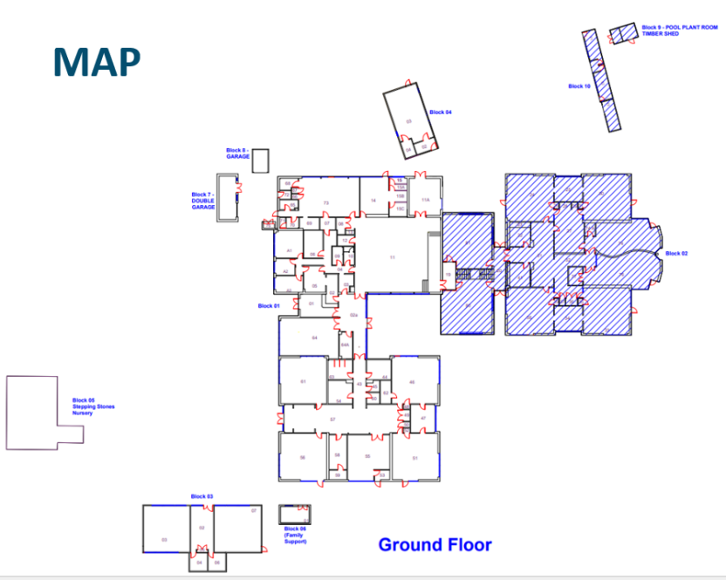

20. Where can I find further information about the school’s approach to pupils with SEND?

Full details can be found in the school’s SEND policy, which is available on the school website:
SEN and disabilities Policy 2025

21. How accessible is this report?
Please note that this SEN Information Report is available in hardcopy format from our school office. Should you require an enlarged copy, please ask at reception. Whilst we do not have current translations, this can be facilitated should it be required. Should you require any other adaptation to this report, please speak to the SENCO, Lisa Birnie, who will be happy to oblige.

Many thanks to Mrs M and Mrs D for agreeing to read, review and offer suggestions to this report.

Your consideration and suggestions around accessibility photographs and maps were greatly appreciated. We have adapted the report to reflect your suggestions (as detailed in point 19).

Your time and attention were greatly appreciated!

~ Parent Testimonial ~
"The confidence is noticeable and the overall love of going to school, is the confirmation that Elburton was the right choice. The support given not only to my son but also us as a family, has enabled the SEND journey to be a little less scary and a little less lonely. Communication between school and home is so important. The approachable staff at Elburton have made it easier to talk about the strategies which work at home and could help in school, but also gain invaluable advice on what can be introduced at home that works in the classroom. Every SEND journey is an individual and Unique one, but Elburton Primary has encouraged a great start, a learning journey offering opportunity and inclusion"

~ Parent Testimonial ~
“ ‘It takes a village to raise a child’. This we all know is true. When we found Elburton School we found our village. Our child has extensive additional needs and requires a lot of extra support. Part of his disabilities means that currently he finds it incredibly hard to form words. How can you send a child to school who cannot verbalise? We were concerned to say the least. ‘He’s doing just fine’. This we were reassured of on our very first walk around with Mr Smithers.
Elburton has succeeded where others have failed, because they care a great deal about each and every one of the children in their care. Inclusion isn’t a buzz word, but a way of life. It’s raw, it’s real and they often make us emotional. In a good way of course!
Their open door policy is also, it would seem, an all hours policy. We have on many occasion kept a teacher way past their home time or had a response to a message in the evening when you could expect that they are off duty. Support is there when you need it.
They go above and beyond to tailor our child’s learning journey to support him best. Their can do attitude means that our child is growing in confidence every day. He has a very long way to go, this is true, but we have every faith in the incredible team at Elburton.
Before starting at the school we had hoped that he could make a friend. He has so many and really enjoys coming to school. To be completely honest we have to forewarn of upcoming holidays as school is his favourite place to be. He’s happy and when a child is happy and supported, they can achieve their full potential. There will be hurdles that need jumping along the way, but he has a lot of people cheering him on.
Elburton school is a wonderful community and one that we are proud to be a part of. We will forever be incredibly in their debt.”

